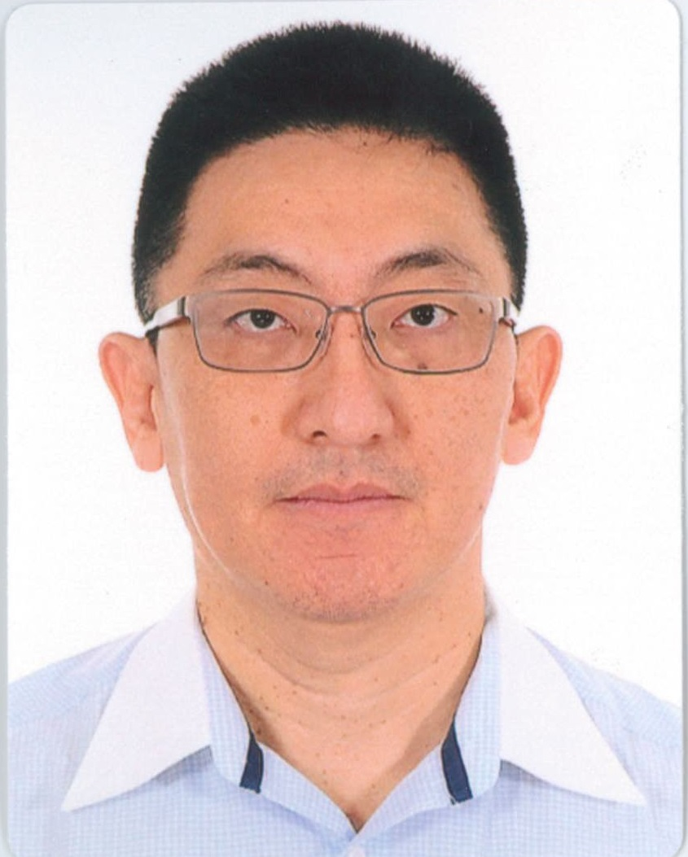  Objective  To be internal and external stakeholders’ one stop point of reference for all corporate actions.  CORPORATE GOVERENANCE  DRAFTING  DATA SECURITY  CONTACTS  RISK MANAGEMENT  COMPLIANCE  M&A  POLICIES  COMPANIES ACT  TRUST  JOINT VENTURES  ISDA  Currently  Senior Legal Counsel for Major Commodity Trader (NYSE Listed Fortune 500),  Review, draft, negotiate and mange legal agreements and contracts in support of soft oils, grains and oilseed trade. | Recent Work Experience  Senior Legal Counsel • [Major COMMODITY TRADER listed on NYSE]  • Dec 2016– present (on Fixed Term Contact)  - Negotiate, review, draft and manage legal agreements in support of Commodity Trading business.  - Advise on Data Protection, HSR, AML, EU sanction and other regulations.  - Various projects as assigned from time to time.  Company Secretary VP Corporate • Olam International Ltd  • Feb 2015 – May 2016  - Manage a team of 4 professional staff out of Singapore Head Office. (Group comprises some 270+ subsidiaries and associates in 73 countries).  - Responsible for delivery of service standards for corporate governance, including training, mentoring and troubleshoot internal controls policies etc.  - Provide contract and legal support to the Sales Team and Management on all business operations and activities.  Group General Manager, Corporate • International SOS Pte Ltd • Apr 2013 - Jan 2015  - Manage the establishment, organization and statutory reporting on 230 legal entities across 70+ jurisdictions; restructuring system and policies for corporate statutory records, and licences required for medical operations.  - Internal review of corporate policies compliance, trouble shoot risk governance and data management.  - Advise and support BU on various data protection issues including impact to various BU.  Company Secretary / Legal Manager • Wilmar International Ltd  • Mar 2006 = Apr 2013  - Provide active support to the Board of Directors in their legal and fiduciary role under the SGX rules, relevant statutes & regulations.  - Extensive experience in Negotiating, Drafting, Reviewing and managing complex Contracts, Agreements & Documentation for Operational, Trade and Banking related matters including (among others) Master Supply, SLA, NDA, Joint Ventures, Trade Facilities, BOT, PPP, Bank Facilities Term sheets, Ship Manufacture, Aircraft Ownership & Management, Intellectual Property and Trade Secrets Agreements.  - Advise and manage supervise SGX disclosures (Announcements etc.), legal reporting and regulatory filing requirements.  - Support of BU operations including negotiations with key stakeholders. Types of BU include manufacturing, IT 3rd party service providers and sales & marketing functions.  - Attend to Board, Committee and Shareholders Meetings, arrange board papers and ensure issues are kept confidential.  Company Secretary / Legal Manager • Continental ChemicaLS cORP pTE lTD • Feb 2003 - Mar 2006  - Negotiate, draft and deliver series of turnkey EPC contracts for Specialty Chemicals Business totaling US$200m  Corporate Secretary / Legal Officer • rgm iNTERNATIONAL lIMITED  • Jul 1997 - Feb 2003  - Establish corporate secretarial procedures and processes with adequate documentation which promote efficiency and accountability.  Various Corporate Secretarial Roles • Sept 1990 - Jul 1997  - Administer corporate secretarial function under the Companies Act.  (details of work experience available upon request)  Education  Bachelor of Arts (Honours) Law and History • 1990 • Oxford Brookes University  Studied in UK for 3 years before returning to Singapore to commence working life.  Graduated and Elevated to Associate Member (ACIS) • 2001 • sINGAPORE Association of Chartered Secretaries and Administrators (SAICSA)  Professional Qualification to act as Company Secretary under s.171 of the Companies Act. Elevated as Associate Member after no less than 6 years relevant working experience.  achievements  M&A Corporate Actions  - Reverse Takeover of Ezyhealth Asia Pacific Limited (subsequently renamed ‘Wilmar International Limited’), US$1.2 b.  - Acquisition of PPB OilPalms Berhad– US$1.1 b.  - Merger with Kuok Oils & Grains Pte Ltd and PGEO Group Sdn Bhd– US$1.6 b  - Acquisition of Wilmar Holdings Pte Ltd’s interests in its subsidiaries and associated companies in China S$1.7 b.  - Acquisition of all of Archer Daniels Midland Asia Pacific’s interest in its China Assets S$730.6 m.  FINANCE RELATED  - Establish club deal for Loan Facility of US$1 Billion.  - Issue of US$300,000,000 4.50% fixed rate senior unsecured notes due 2021.  - Establishment of US$650 million revolving credit facility.  AD-HOC PROJECTS  - Overhaul Corporate Reporting and Corporate Governance system for SGX Listed Company; and Design, Implement, Review and Enforce Corporate Governance policies for SGX Listed Company.  - Establish corporate policies, review and audit compliance with existing policies, procedures and processes for multinational company.  - Portfolio review of 3,500+ trademark registrations in some 60+ countries.  - Ship Building contracts negotiation for 8 kansaimax class bulk carriers with option for additional 4 vessels.  - Aircraft Operators’ licence (part 135 exemption) for deployment into Indonesia.  - Specialty Fats, Intermediate Petrochemicals and Bio-diesel start-up projects, including establishment carbon capture credit capture mechanism.  - Establish agreement structure for USD1b aromatics complex (specialty chemicals) greenfield project.  - Review, negotiate and support extensive BOT, PIP and other forms of facilities construction agreements for commodities, manufacturing and production businesses.  - Establishment of contract base for offshore service support business (out sourcing).  - Establishment of captive insurance entity with relevant permits and licences.  - Manage implementation of Integrated Reporting regime for annual reporting to shareholders.  Invited as Guest Speaker:  Best Practices for Corporate Counsels  13/14 February 2012 Sheraton Towers, Singapore  Topic Presented: An Inter-Disciplinary Approach to Risk Management  – Perspectives from the Commodities Market
  colin Tan
  Corporate Legal &
  Chartered Secretary | HP 9652 9089

